Creating New Report Screen

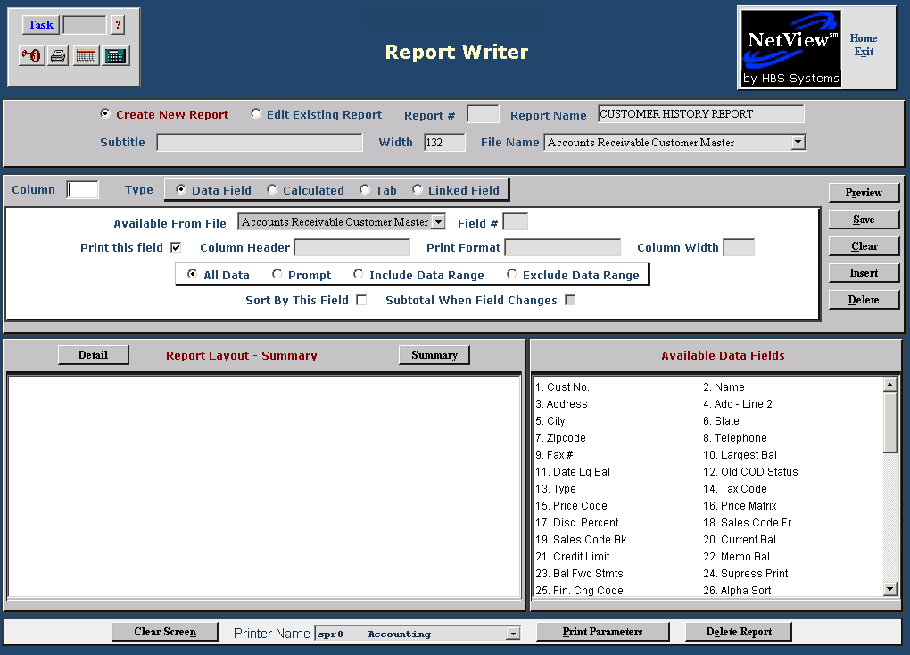
Here you will specify what fields to include on the report and how you want them handled, formatted, and printed.
Start by selecting a field for your report from the box in the lower right hand corner. Click on it to add it to the report.
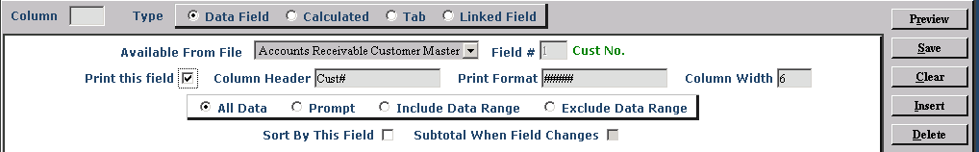
This center panel is where you format the selected line to your liking. Select one of the four field types by clicking on the circle next to its name, and the panel will change to reflect your chosen type.

Data Field: This field type refers to the fields that you can select from the collection in the lower right hand corner of the screen. They are usually numbered beginning with 1.

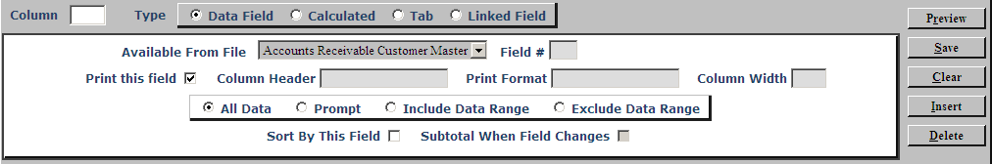

Available from File: This field indicates which data file the field belongs to. When multiple files are used for a report, it is useful to know where the information is coming from. For multi-file reports, the drop-down menu here shows all the files used for the report.

Field #: This shows the field number from the selection panel in the lower right corner. To the right of this field, you will see the field name that matches the number.

Print this field: This box is checked by default, but you can uncheck it if you do not want to print a particular field.

Column Header: This is the system-provided heading for the column on the report. You can change it as needed.

NOTE: Remember that the column width on your report is determined by the width of the Heading Name or the data itself. If you choose a long column name for a field with small data, you may waste valuable space on your report page.

Print Format: For many fields, this area shows the layout of the data for the field. For the “Cust No.” field, it shows #####, which means that it is 5 characters wide. For a dollar amount field, it might show ########.##, indicating there is a decimal place in the field preceded by space for a large number. You may change this field as needed, but be careful, as you may shorten it too much and truncate the information it contains.

Column Width: This is a companion field to “Print Format.” It indicates how many characters the information occupies. If you shorten the print format, you need to adjust this as well.

All Data / Prompt / Include Data Range / Exclude Data Range: These choices give you the ability to restrict the information included on the report.

All Data: Selecting this option will print all information available for the selected field.

Prompt: When you choose this option, it will cause the report to stop when it is run and ask if you want to include all or some of the information for this field. This is a good choice if you want to vary the information for this field or want to use the report for more than one purpose or time. For example, if you prompt on a date field, you can use this report many times, as it can now include any date range.

Include Data Range: Selecting this option will allow you to include only the values within a specific range. Fill in the smallest value and largest value fields to limit the information that will print on the report. For instance, you could limit it by date to cut down on unneeded information.

Exclude Data Range: Selecting this option will allow you to exclude values within a specific range. Fill in the smallest value and largest value fields to exclude from the report. For instance, if you wanted a report of customers outside your town, you could exclude the city name or zip code.

Sort By This Field: Check this box if you want to report sorted by the selected field.

Subtotal When Field Changes: If you have dollar amounts in your report, you can have them subtotaled when values in the field change by checking this box.
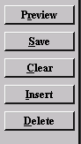

Save: Click “Save” to save the line you added or edited.

Preview: Click “Preview” to check the report layout: how the report is spaced out and how much room is left on the page.

Clear: Click “Clear” to clear the entries on the column being worked on. NOTE: It only clears the entries from this area, not from the report.

Insert: Click “Insert” to place the column being created someplace other than as the last column of the report. Choose between:
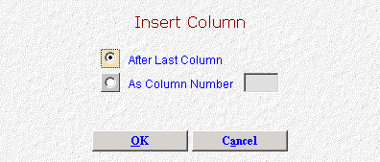
- After Last Column
- As Column Number (choose the column number where you want to place it)

Delete: Click “Delete” to delete the column details shown.

Report Layout Summary:
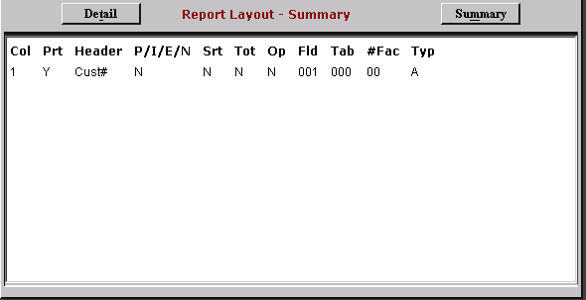
Once a column is saved, the details are added to the Report Layout Summary in the lower left hand corner of the screen. It includes:

Col: Indicates the column position for the field on the report.

Prt: Indicates if the field will be printed on the report.

Y=Yes

N=No.

Header: Shows the heading that will print for the column.

P/I/E/N: This shows how much data will display

P=Prompt

I=Include

E=Exclude

N=No exceptions (shows all data).

Srt: Indicates if the column is to be used for sorting.

Y=Yes

N=No

Tot: Shows whether or not you chose to have the program subtotal the data when it changes

Y=Yes

N=No.

Op: This section is active when the column is a calculation. It shows:

+ for addition

- for subtraction

/ for division

* for multiplication.

Fld: Shows the field number selected for the column.

Tab: Shows the tab column selected if a tab has been specified.

#Fac: This section is active when the field is a calculation, and it indicates the number of factors present.

Typ: This shows the data type.

I=Integer

D=Date

N=Numeric

F=Floating point

A=Alpha

T=Telephone

Clear Screen: Click this button at the bottom of the screen to clear the report from the screen. It does not delete the report, just clears the space.

Print Parameters: This field works with the Printer Name field to the left. It generates a list of the parameters you specified for the report.

Delete Report: Click this to delete the report displayed on the screen.

Calculated Field: This field type allows you to perform calculations using the elements of the data files or numbers you provide. By choosing this type you “create” a column with the calculation.

You may perform one calculation per column.

If you need to apply additional calculations to the result, you can create additional columns to use the result from a previous calculation.
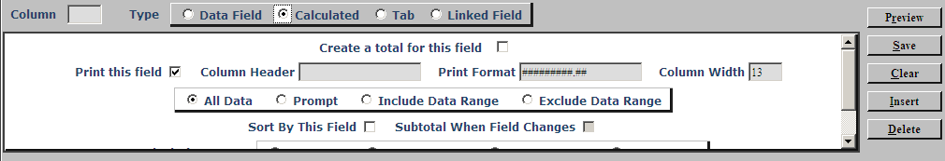

Create a total for this field: Check this box to add the total, or leave it blank to skip the total.

Print this field: Check this box to print this calculated field on the report.
Column Header: Name the calculated column. It only prints if you have indicated so.
Print Format: It defaults to a format that includes 2 decimal places. You may change it as needed.
Column Width: This field works with the “Print Format” field and defines the width the column. NOTE: A general rule is to add 2 to the widest data you anticipate for the column and adjust “Print Format” accordingly.
All Data / Prompt / Include Data Range / Exclude Data Range: These choices give you the ability to restrict information to be included on the report.

- All Data: Selecting this option will print all information available for the selected field.
- Prompt: Choosing this option causes the report to stop when it is run and ask if you want to include all or some of the information for this field. This is a good choice if you want to vary the information for this field or want to use the report for more than one purpose or time. For example, if you prompt on a date field, you can use this report many times as it can include any date range.

Include Data Range: Selecting this option will allow you to include only the values within a specific range. Fill in the smallest value and largest value fields to limit the information that will print on the report. For instance, you could limit it by date to cut down on unneeded information.

Exclude Data Range: Selecting this option will allow you to exclude values within a specific range. Fill in the smallest value and largest value fields to exclude from the report. For instance, if you wanted a report of customers outside your town, you could exclude the city name or zip code.

Sort By This Field: Check this field if you want to report sorted by this field.
Subtotal When Field Changes: If you have dollar amounts in your report, you can have them subtotaled when values in the field change by checking this box.

Calculation Type: Choose the calculation type needed.

- Add (+)
- Subtract (-)
- Multiply (*)
- Divide (/)

Number of Factors: Enter the number of factors you will use in your calculation. If you are going to add two fields together, you enter 2. If you are going to add 8 fields together, you enter 8.
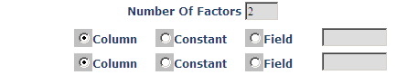
For each factor used, you define what item to use as part of the calculation.
- Column: Choose this factor if the item to use is present ONLY in a column of your report. For example, if you are using a previously calculated column as part of this calculation.
- Constant: Choose this factor if the item to use is a number you supply. For example, if you want to multiple a number by 100 to more correctly display a percentage, the constant would be 100.00 in this case.
- Field: Choose this factor if the item to use is part of your data fields.

Save: Click “Save” to save the line you added or edited.

Preview: Click “Preview” to check the report layout: how the report is spaced out and how much room is left on the page.

Clear: Click “Clear” to clear the entries on the column being worked on. It clears the entries from this area, not from the report.

Insert: Click “Insert” to place the column being created someplace other than as the last column of the report. Choose between:
- After Last Column
- As Column Number (choose the column number where you want to place it)

Delete: Click “Delete” to delete the column details shown.

Tab Field
We do not recommend use of a Tab Field at this time.

Linked Field (Multi-file Reports): A number of data files offer a linked field that ties information in that file to others with a link from a common field. When you choose this field type, you gain access to the linking capability.
We recommend that the first field on your report be one that “links” the data files together. For instance, if you are creating a report with customer and unit information, put the “Cust#” linked field first on your report. You can even choose not to print it, but make sure it is included first on the report.
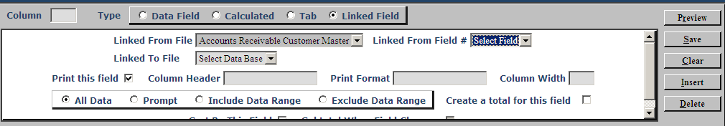
When you choose Linked Field, the selections in the center panel change so you can specify the files and fields needed for your report.

Linked from File: This drop-down menu will show the available files from which you can choose fields to include in your report. Initially, it will show only the data file you selected in the header. As you “link” to other fields, the drop-down menu may show additional selections.

Linked from Field #: This drop-down menu shows the available fields to link to other data files. Some offer only a single field, while other files have several fields to link across. Choose the one that best suits your needs.

Linked to File: Once you have selected a field from the “Linked from Field #” menu, this drop-down menu shows the data files you can draw from. It will show 2 or more data files when you have specified a field to link, provided that field can link to other fields.
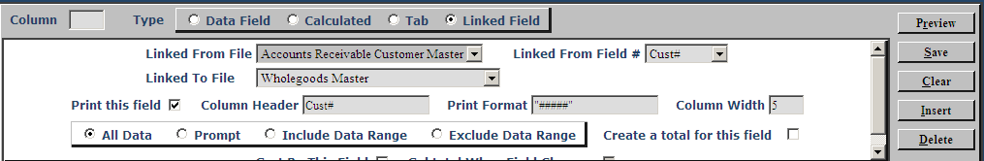
- If you are NOT going to have the linked field print on your report in this position, uncheck the “Print this field” box and press “Save.”
- If you are going to have the linked field print on your report, continue with the remaining format/data choices.
Once you have linked to the file, you may select information to appear on your report. You can use any of the files available in the “Linked from File” drop-down menu to make your selections. For example, if you started with the Accounts Receivable Customer Master, the list of choices in the lower right hand corner might look like this:
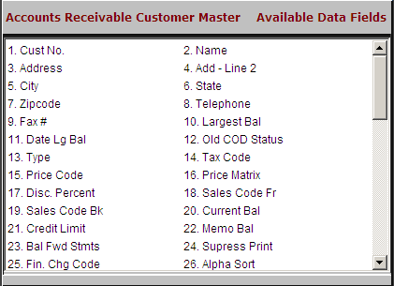
From this collection of fields, you may choose the ones you want for your report. You may also “change” data files by selecting a different one from the “Available from File” drop-down menu, and pull some of those fields into your report as well.
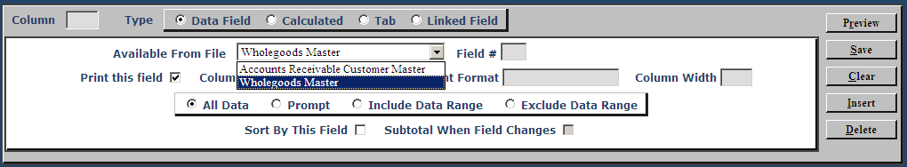
If you select the Wholegoods Master, as shown above, your choices in the lower right change to the fields from the data file.
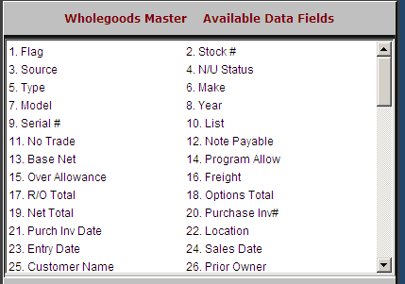
Continue to add fields to the report using the “Available from File” drop-down menu and the choices they provide in the lower right panel.

Print this field: This box is checked by default, but you can uncheck it if you do not want it to print

Column Header: The system-provided heading for the column on the report. You can change it as needed. NOTE: Remember that the column width on your report is determined by the width of the Heading Name or the data itself. If you choose a long column name for a field with small data, you may waste valuable space on your report page.

Print format: For many fields, this area shows the layout of the data for the field. For the “Cust#” field, it shows #####, which means that it is 5 characters wide. For a dollar amount field, it might show ########.##, indicating there is a decimal place in the field preceded by space for a large number. You may change this field as needed, but be careful, as you may shorten it too much and truncate the information in it.

Column Width: A companion field to “Print Format.” It indicates how many characters the information occupies. If you shorten the print format, you need to adjust this one as well.

All Data / Prompt / Include Data Range / Exclude Data Range: These choices give you the ability to restrict information to be included on the report.

All Data: Selecting this option will print all information available for the selected field.
- Prompt: When you choose this option, it will cause the report to stop when it is run and ask if you want to include all or some of the information for this field. This is a good choice if you want to vary the information for this field or want to use the report for more than one purpose or time. For example, if you prompt on a date field, you can use this report many times as it can include any date range.

Include Data Range: Selecting this option will allow you to include only the values within a specific range. Fill in the smallest value and largest value fields to limit the information that will print on the report. For instance, you could limit it by date to cut down on unneeded information.

Exclude Data Range: Selecting this option will allow you to exclude values within a specific range. Fill in the smallest value and largest value fields to exclude from the report. For instance, if you wanted a report of customers outside your town, you could exclude the city name or zip code.

Sort By This Field: Check this field if you want the report sorted by this field.

Subtotal When Field Changes: If you have dollar amounts in your report you can have them subtotaled when values in the field change by checking this box.

Save: Click “Save” to save the line you added or edited.

Preview: Click “Preview” to check the report layout: how the report is spaced out and how much room is left on the page.

Clear: Click “Clear” to clear the entries on the column being worked on. It clears the entries from this area, not from the report.

Insert: Click “Insert” to place the column being created someplace other than as the last column of the report. Choose between:
- After Last Column
- As Column Number (choose the column number where you want to place it)

Delete: Click “Delete” to delete the column details shown.

Report Layout Summary:
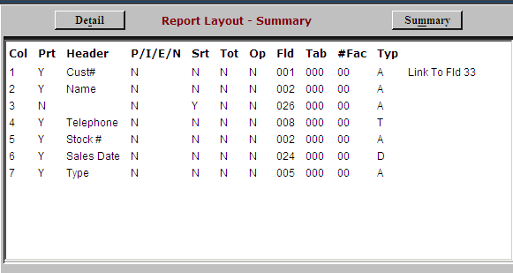
Once a column is saved, the details are added to the Report Layout Summary in the lower left hand corner of the screen. It includes these details:

Col: Indicates the column position for the field on the report.

Prt: Indicates if the field will be printed on the report.

Y=Yes

N=No.

Header: Shows the heading that will print for the column.

P/I/E/N: This shows how much data will display.

P=Prompt

I=Include

E=Exclude

N=No exceptions (shows all data).

Srt: Indicates if the column is to be used for sorting.

Y=Yes

N=No

Tot: Shows if you chose to subtotal the data when it changes or not.

Y=Yes

N=No.

Op: This section is active when the column is a calculation. In that case, it shows:

+ for addition

- for subtraction

/ for division

* for multiplication.

Fld: Shows the field number selected for the column.

Tab: Shows the tab column selected if a tab has been specified.

#Fac: This section is active when this is a calculation, and it indicates the # of factors.

Typ: This shows data type.

I=Integer

D=Date

N=Numeric

F=Floating point

A=Alpha

T=Telephone

Clear Screen: Click this button at the bottom of the screen to clear this report from the screen. It does not delete the report, only clears the space.

Print Parameters: This field works with the “Printer Name” field to the left. It generates a list of the parameters you specified for the report.

Delete Report: Click “Delete Report” to delete the report displayed on the screen.

